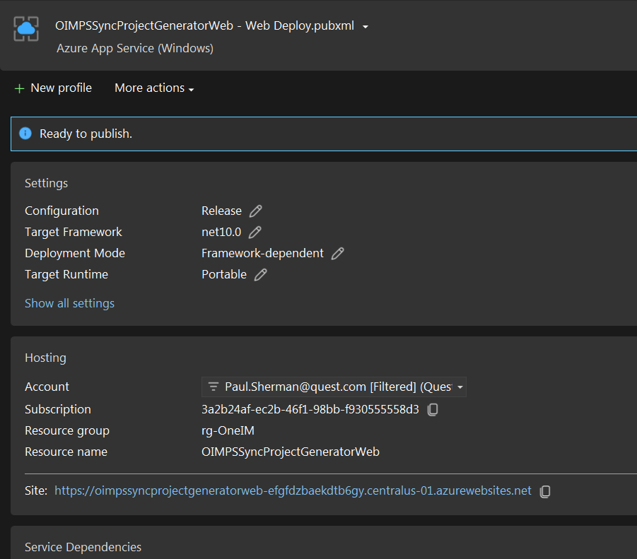
Subscription: 3a2b24af-ec2b-46f1-98bb-f930555558d3
Site: https://oimpssyncprojectgeneratorweb-efgfdzbaekdtb6gy.centralus-01.azurewebsites.net

